ROLLS-ROYS VS MACEDES

[BUYER’S GUIDE BOOK]

SENRIN SIM-CLASS B

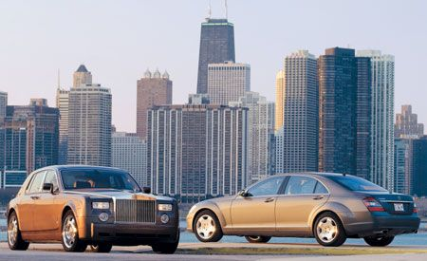

Table of Contents

I. Presentation of the products 2

1. The Rolls-Roys car 2

2. The Macedes car 2

II. Which car should you buy ? 3

III. Let s talk to car suporting fan ! 4

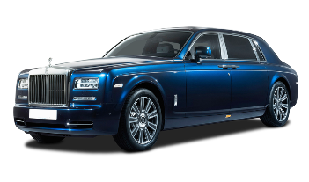

# Presentation of the products

## The Rolls-Roys car



**Rolls-Royce** was a British luxury car and later an aeroengine manufacturing[1] business established in 1904 in Manchester by the partnership of Charles Rolls and Henry Royce. Building on Royce's good reputation established with his cranes, they quickly developed a reputation for superior engineering by manufacturing the "best car in the world". The business was incorporated as "Rolls-Royce Limited" in 1906, and a new factory in Derby was opened in 1908. The First World War brought the company into manufacturing aero-engines. Joint development of jet engines began in 1940, and they entered production in 1944.[[1]](https://en.wikipedia.org/wiki/Rolls-Royce_Limited#cite_note-1) Rolls-Royce has since built an enduring reputation for the development and manufacturing of engines for military and commercial aircraft.

## The Macedes car

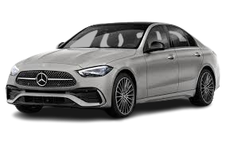

**Mercedes** and sometimes as **Benz**, is a German luxury and commercial vehicle automotive brand established in 1926. **Mercedes-Benz AG** (a Mercedes-Benz Group subsidiary established in 2019) is headquartered[2] in Stuttgart, Baden-Württemberg, Germany. Mercedes-Benz AG produces consumer luxury vehicles and commercial vehicles badged as Mercedes-Benz. From November 2019 onwards, Mercedes-Benz-badged heavy commercial vehicles (trucks and buses) are managed by Daimler Truck, a former part of the Mercedes-Benz Group turned into an independent company in late 2021.

# Which car should you buy ?

Rolls Royce are better than Macedes banz. luxury and build massive powerful engines. Mercedes is top notch luxury no doubt, Rolls Royce has been a luxury brand for so long that they have this charm, a royalty to the way it looks. It has street presence that no other car can have in that segmen.

|  |  |  |  |
| --- | --- | --- | --- |
|  | Rolls-Roys | Macedes banz | Which car that is better. |
| Cost | $$$$$ | $$$$$ | Rolls Roys |
| Max Power | 563bhp@5000rpm | 362.07bhp@5500-6100rpm | Rolls Roys |
| Rating |  |  | Rolls Roys |
| Drive Type | RWD | AWD | Rolls Roys |
| Engine Displacement | 6749 cc | 2999 cc | Rolls Roys |





# Let s talk to car suporting fan !



The Rolls Roys is my favourite car in my dream.

I fell like this car is has security when we drive it, and it’s a modern car.

And it’s a famus brand car in the world. A lot people also like this car like me.

I like macedes because it’s a famus brand in the world, and it’s luxiry for me. I love this car since I was a kid.

When see this car I’m every exciting. And I want it after I finesh school, I will buy it for my life in the future.

1. The making of articles on a large scale using machinery; industrial production.
2. Headquarters at a specified location.